Planning for Learning

BTEC Level 3 Applied Science

Bev Chandler

The Studio & Life Sciences UTC

Table of Contents

1.Sequencing Statement 1

2.Specialism Statement 1

3.Curriculum on a Page 2

4.Knowledge Acquisition and Routines 3

5.Literacy 3

6.Resources 3

8.Syllabus 4

9.What Will I Learn? 4

10.How Will I Be Assessed? 5

11.How Will This Prepare Me for My Next Steps? 5

12.Contribution to UTC & Studio Aims 5

13.Career Planning 6

# 1.Sequencing Statement

Carefully considered sequencing in Applied Science is imperative as many of the topics covered build on some prior knowledge. The content is sequenced in such a way as to ensure knowledge is built over time, and previous learning is referenced in order to allow learners to make links and recognise how their knowledge is building.

Learners’ GCSE Science knowledge is the prior learning that will be built upon, starting in the first term with the Principles and Applications of Science examination unit. This draws, reinforces and builds on previous Science knowledge and concepts in Chemistry, Physics and Biology as well as expanding numeracy skills of rearranging equations, reading graphs and using standard form. This unit secures scientific knowledge in preparation for specialist units including physiology of Human Body Systems, Medical Physics and Medical Physics. The Practical Scientific Procedures unit allows learners to develop their practical lab skills, including determination of concentration using titration and colorimetry, determining the rate of cooling of stearic acid and paraffin wax, and identifying plant pigments using chromatography. The development of analysis skills allows learners to explore the scientific method, with numerical skills such calculating rate, concentration, and retention factors being key foci. The Scientific Investigation Skills unit is a core unit that builds on learners previously gained scientific skills and develops their planning, statistical analysis and evaluative skills. This unit is excellent preparation for the Investigative Project unit that involves learners planning, implementing and evaluating their own individual projects, and also for the Laboratory Techniques and their Applications unit that involves learners synthesising an organic solid and liquid. In the second year of the programme learners consolidate their scientific knowledge and further develop their literacy skills undertaking Contemporary Issues in Science unit that expand learners’ knowledge further in relating to real life scientific issues including plastic waste in the ocean, GM crops and carbon capture. Learners review journals to extract implications about these issues and make judgements on validity of scientific evidence provided based on the quality of the scientific evidence provided. This unit builds prior knowledge for the Materials Science unit that includes nano materials and polymers. Along side this unit, the Principles and Applications of Science II core unit introduces learners to some more advanced Chemistry, Physics and Biology topics to develop and expand their problem solving skills further to embed topics including thermal physics, fluid mechanics and material physics, electrolysis, organic chemistry, energetics, the heart and kidneys. Further specialised coursework units including Human regulation and Reproduction and Forensic Evidence, collection and analysis draw on knowledge and skills from previous units.

# 2.Specialism Statement

The Applied Science team takes pride in demonstrating and encouraging a love of learning. The routines and programme we have in place encourage learners to take control over their own learning and develop an autonomous approach to their studies. We strive to provide an environment where the teaching is guided by the learning in order to ensure all learners progress in both their studies and their journey to becoming an effective independent learner.

# 3.Curriculum on a Page

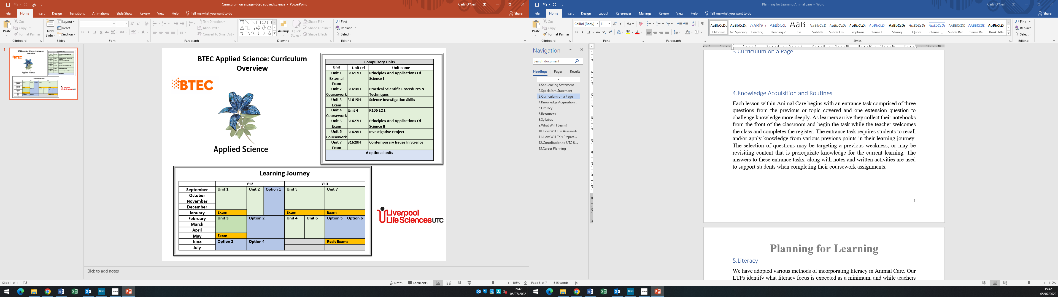

# 4.Knowledge Acquisition and Routines

In the first examination unit lesson learners receive a unit plan showing them the topics that they will be learning every session and the dates that they will be assessed, with mock and final examination dates. Each lesson in Applied Science Starts with an entrance task, which is on the first page of the session booklet and comprises of a structured 6 mark examination question based on the topic from the previous lesson. As learners arrive, they collect their workbook from the front of the classroom and begin the task. The workbooks tie in with the topic power point presentations that are used in the session and are structured, containing the entrance task, key words and diagrams, space for notes and a bank of practice questions targeting weaknesses for the learner to engage with.

In the first coursework unit lesson learners receive a unit plan showing the practical, theory and supported coursework lessons with coursework deadlines. Theory sessions are similar to examination unit lessons, and practical sessions always begin with either a health and safety activity or briefing and a practical demonstration of the activity that the learners are to undertake. Class notes, experimental procedures, results, conclusions and evaluations carried out in class are all used by the learners as part of their coursework with additional tutor observations for support.

# 5.Literacy

We have adopted various methods of incorporating literacy in Applied Science. Our LTPs identify what literacy focus is expected as a minimum, and while teachers are free to incorporate this as they see fit the expectation is that the literacy focus be present.

Our simplest approach is a spelling focus. The LTP will identify keywords that we wish to highlight the spelling of, along with any common mistakes when spelling the words. These will be visible on the slides or materials used in the lesson.

We have also incorporated activities looking at the morphology and/or etymology of some of the tier 3 language. This might include breaking words down into their parts, or perhaps focusing on a particular prefix or suffix to show the building of words.

Command words are also a focus that we have incorporated into LTPs, and are very important in coursework as they direct the learner to the way that the coursework is presented to meet the criteria. In terms of both their meaning and how to structure responses to various command verbs for example using a spider diagram to identify, tables to evaluate, concept maps to discuss and venn diagrams to compare similarities and differences. first focusing on something familiar to explore the response structure and then transferring this skill to a more scientific context.

# 6.Resources

Learners studying BTEC Applied Science have access to a wealth of resources to support their studies, both throughout the course and for revision.

Applied Science make good use of the google classroom platform. All lesson resources are shared via the google classroom, along with useful videos and web links to help both revision and for learner that is absent.

Learners also have access to a bespoke set of resources given in hard copy in classes but available on the Google Classroom platform as well as revision packs issued in order to prepare students for their external exam. The resource packs are organised by topic, and each topic section contains:

* Revision notes, definitions and flashcards
* YouTube playlists
* Worksheets and answers
* Past paper questions
* Model answers & Mark schemes
* Links to any other useful videos from external sources

# 8.Syllabus

We follow the Pearson BTEC L3 (601/7437/7) specification for Applied Science, which can be found here:

<https://qualifications.pearson.com/content/dam/pdf/BTEC-Nationals/Applied-Science/2016/specification-and-sample-assessments/BTEC-L3-Nat-ExtDip-in-Applied-Science-Spec.pdf>

# 9.What Will I Learn?

A wide scientific knowledge and practical skills sets that can be used to support progression in a range of science careers and to gain entry to university courses. Applied science consists of a range of pure science, chemistry, biology and physics and specialist science subjects including physiology, medical physics and material physics. Critical and analytical thinking skills will also be developed and applied in different contexts throughout the course. Examinations will prepare learners for assessment at university whilst practical skills and development of general skills will prepare learners for working in the scientific industry.

The content of this course is split into 13 topics with 4 examination and 9 coursework topics that are spread out over the two year duration of the course.

Examination units include:-

Principles and Applications of Science I

Science Investigation Skills

Principles of Applied Science II

Contemporary Issues in Science

Coursework units include:-

Practical Scientific Procedures and Techniques Science Investigation Skills

Laboratory Techniques and their Applications

Investigative project

Physiology of Human body systems

Human Regulation and Reproduction

Diseases and Infections

Medical Physics Applications

Materials Science

Forensic Evidence, Collection and Analysis.

# 10.How Will I Be Assessed?

There are 4 units of external examination units and 9 internal coursework units (3 compulsory and 6 optional) over a two year period. The units are arranged in such a way that learners can concentrate on examination units at particular stages of the course and coursework is scheduled around exams, and marks from both exams and coursework results contribute directly to the overall BTEC profile grade. The spread of units across the two year period reduces the exam pressure of the qualification and students benefit from continual progress that they can directly control.

# 11.How Will This Prepare Me for My Next Steps?

BTEC Applied Science provides a varied range of knowledge and skills necessary for learners to progress to different areas of study including universities, Apprenticeships and jobs. The wide range of practical and theoretical scientific activities undertook throughout the course help learners to build their knowledge and develop skills that will prepare them for the scientific workplace or for higher education.

# 12.Contribution to UTC & Studio Aims

The BTEC qualifications have a diverse selection of subjects that can be used to stretch and enhance our knowledge of the world around us. We provide an inclusive learning experience supporting learners to develop in physical and theoretical studies with expert guidance from staff to help students to exceed their own expectations by continuously pushing their limits.

The BTEC qualification also supports learners with their self management skills that the qualification structure can help them to become more independent learners in control of their academic progression into university.

# 13.Career Planning

Common degrees undertaken by recent BTEC Applied Students included Pharmacy, Engineering, Associate Practitioner and Biomedical science. Other careers accessible with a BTEC L3 Applied Science include Environmental Scientist, Physiology and Criminology, Engineering, Teaching & Education, Forensic Science, Animal Management & Zoology, Nursing, Radiotherapy, Lab science and food and nutrition and many more…..